**ASSIGNMENT 11**

1. **Find the Minimum Marks and Maximum marks scored by each student.**

|  |  |  |  |  |  |  |  |  |  |
| --- | --- | --- | --- | --- | --- | --- | --- | --- | --- |
| ROLL NO | NO OF STUDENT | SUB-1 | SUB-2 | SUB-3 | SUB-4 | SUB-5 | SUB-6 | MAX | MIN |
| 100101 | Rohan | 72 | 55 | 52 | 69 | 95 | 32 | 95 | 32 |
| 100102 | Mo han | 65 | 51 | 63 | 85 | 71 | 69 | 85 | 51 |
| 100103 | Ravi meheta | 72 | 56 | 78 | 85 | 47 | 68 | 85 | 47 |
| 100104 | Ruby tondon | 68 | 71 | 85 | 84 | 78 | 60 | 85 | 60 |
| 100105 | Radhika gupta | 80 | 78 | 58 | 65 | 68 | 45 | 80 | 45 |
| 100106 | Rakhi | 61 | 78 | 45 | 62 | 75 | 64 | 78 | 45 |
| 100107 | David | 78 | 69 | 96 | 52 | 63 | 87 | 96 | 52 |
| 100108 | mon ika mis hra | 96 | 85 | 86 | 84 | 45 | 63 | 96 | 45 |
| 100109 | Tommy singh | 75 | 63 | 54 | 63 | 61 | 98 | 98 | 54 |
| 100110 | p.rakesh | 63 | 52 | 96 | 87 | 78 | 45 | 96 | 45 |

1. **Calculate the totals for each student, use conditional formatting to highlight the top students who have scored more than 480.**

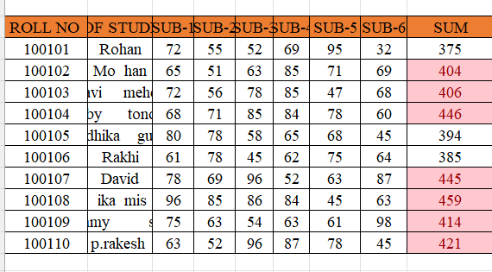

**3.Calculate the length of the names of each student.**

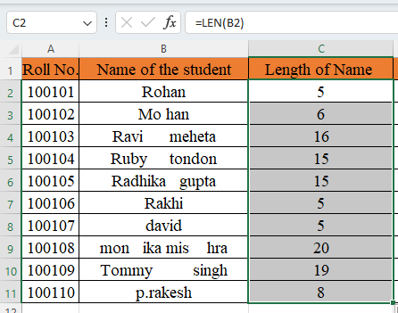

**4. Replace the Name Rakhi with Rocky. Use Formulas**

**5. Combine the Roll Numbers and Names. Use formulas. The end result should look like below.**

**100101Rohan**

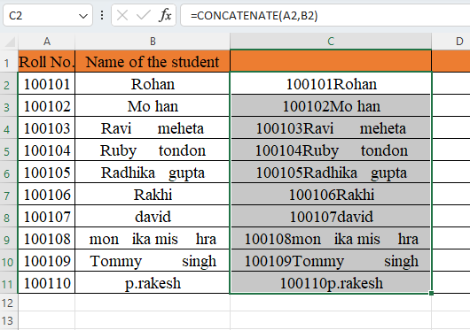

**6. As you can see that some names have spacing issues. Use Formulas to correct that spacing. Also ensure that the names and surnames start with a capital letters**



